Experimental Result
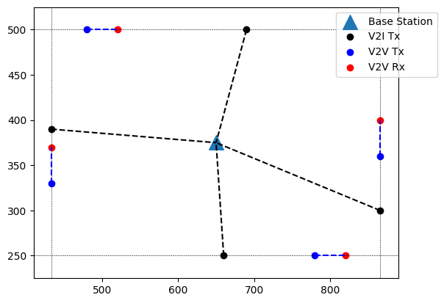
Figure: Random Vehicle Drop in Manhattan Grid

Resource Allocation and Power level selection for V2V link (fixed)

V2I Resource Block: [0, 1, 2, 3]
V2I Power (dB): [23, 23, 23, 23]

Resource Allocation and Power level selection for V2V link (dynamic)
V2V Resource Block: [1, 1, 1, 1]
V2V Power (dB): [23, 23, 23, 23]
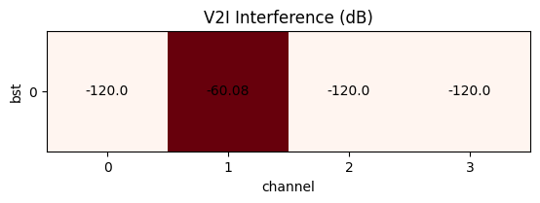 | 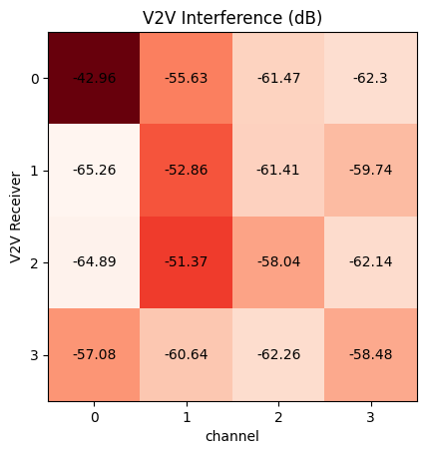
V2I Capacity: [16.1244534 0.40784177 17.79310703 17.6550915 ] Mbps
V2V Capacity: [0.36886057 0.57208674 1.66828855 4.27895252] Mbps

Resource Allocation and Power level selection for V2V link (dynamic):
V2V Resource Block: [1, 2, 0, 0]
V2V Power (dB): [10, 15, 23, 23]
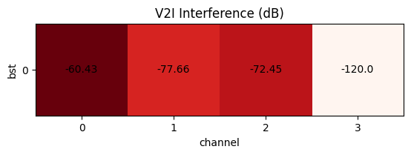 | 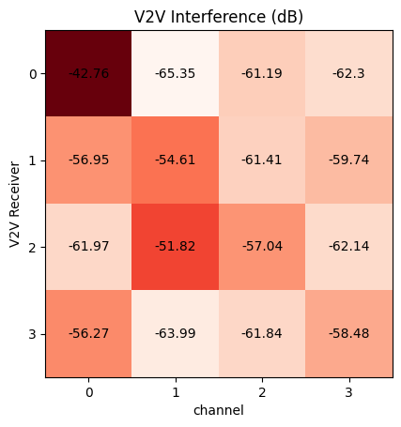
V2I Capacity: [ 0.47762475 4.29866302 4.38301291 17.6550915 ] Mbps
V2V Capacity: [1.90082988 2.16712036 4.70261542 2.95142412] Mbps

